Dungeon of Pixels – User Manual

By Team Keter

If you are using non-Korean version of Windows, you first need to install code page #949 manually before start the game. See README.md on “docs” directory for more detailed information.

This project is based on the MinGW(Minimalist GNU for Windows). It is compiled by TCC(Tiny C Compiler). We provide compiled binary file of this project on “bin/release” directory, but you can manually compile this project by running make.bat on “client” and “server” folder. It will automatically copy data files and compile C codes to the “bin/release” directory.

You can run the program by running “run.bat” file on the “release” directory. You can change the host by editing this file. (You can easily edit this file by text editor. Last line of the file indicates the name of host and port for connection.) This program has server/client structure; therefore, you have to run the server first. After you run the server, you run the client to play actual game. Use arrow keys and enter key to interact with our UI. If you properly start the program, you will see the screen like figure 1. Press enter to see menu. In the menu, you can

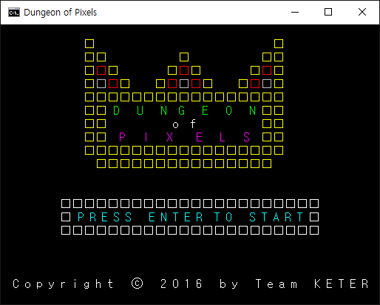

Figure 1. The initial screen

create an account or you can connect to the server with a created account. (You can only use lower case letter for your id. Password will not be encrypted, so do not use your personal information for your password.)

If you success to connect to the server, you will see your position on the map. You can change your position by arrow keys. See figure 2. The player is indicated by unfilled diamond.

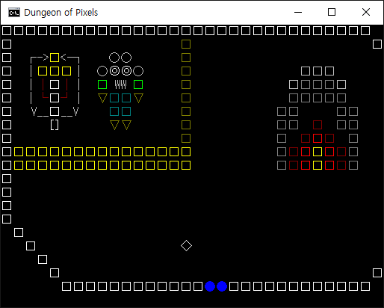

Figure 2. Tiny unfilled diamond indicates you

Other players are indicated by filled diamond.

To access the menu, press enter. See Figure 3. You can use ESC, enter and arrow keys to

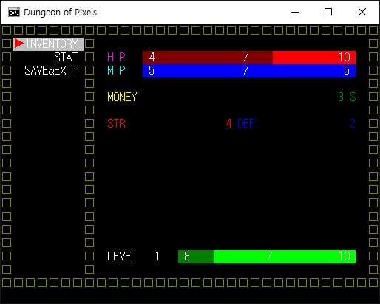

Figure 3. Menu screen

manipulate this menu. However, functions are not implemented yet, so inventory and stat will not operate.

On the field, that is located on the left side of the first village, you can meet monsters. You can attack them by moving toward them. If you attacked them, you will see monster’s information on the top-left corner of the screen. See Figure 4. If you catch the monster, you will

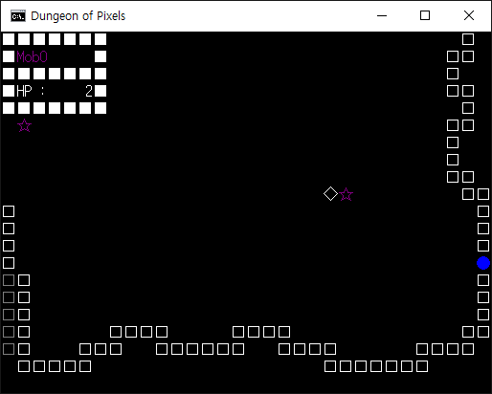

Figure 4. Combat with monster

get EXP and some money.

Basically, this program uses port 2033. You can change this manually. For server, you have to change line 31 of main.c (On SE/Server). Change the parameters for init_server function. For client, change run.bat file. Server is set to localhost(127.0.0.1) and port 2033 initially, you can change this by changing last line of the file. Change “release.exe 127.0.0.1 2033” to “release.exe SERVERIP SERVERPORT” to access another server properly.